1. In the last section, we took a first step at our Dockerfile to build out this Nodejs Project & got this following error msg that is by intention.
2. 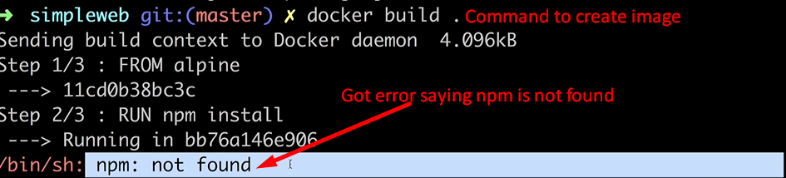
3. 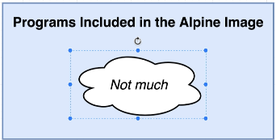
4. 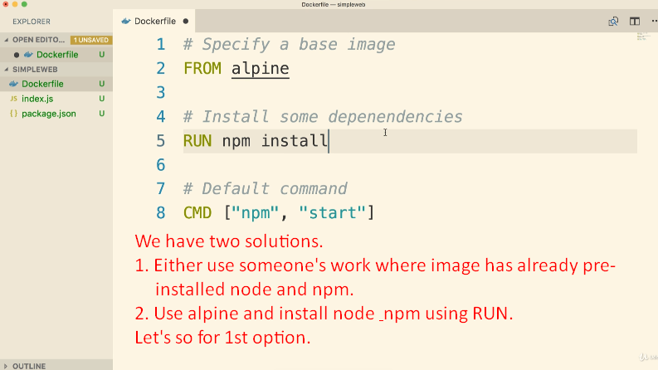
5. 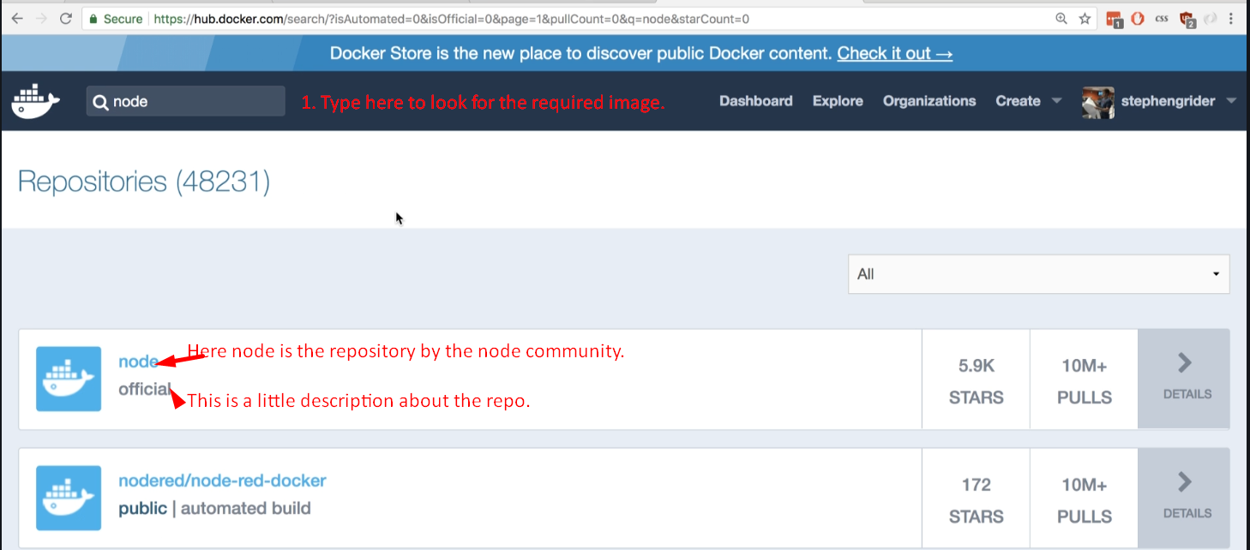
6. This repository is a Docker image that has node pre-installed on it.
7. So, we can create custom image based on this image which has node and npm pre-installed.
8. 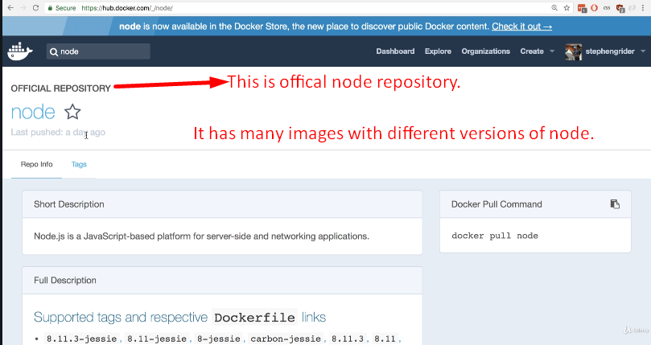
9. 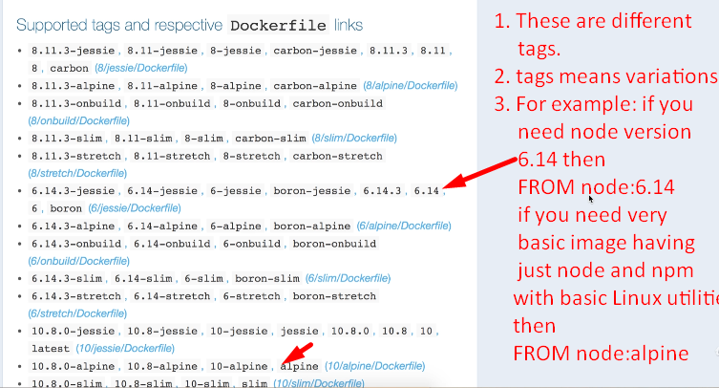
10. 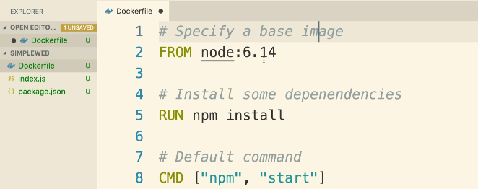
11. 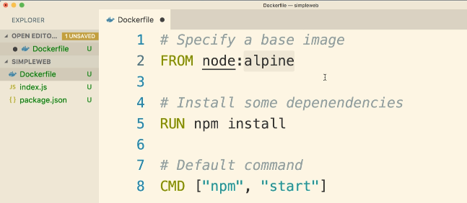
12. 